**Low Level Concerns Policy**

**Introduction**

At Jordans Village Nursery School, we aim to create an open and transparent culture where all concerns about all adults involved with our nursery are dealt with promptly and appropriately. We aim to identify any concerning, problematic or inappropriate behaviour early; minimise the risk of abuse; and ensure that adults working in or on behalf of our nursery are clear about professional boundaries and act within these boundaries, and in accordance with our nursery ethos.

This policy should be read alongside our Safeguarding Children policy and other policies.

1. **Summary**

It may be possible that a member of staff acts in a way that does not cause risk to children, but is however inappropriate. A member of staff who has a concern about another member of staff, volunteer or who, on reflection, recognises that their actions could have been viewed as a risk should inform the nursery manager or the Designated Safeguarding Lead about their concern using a Low-Level Record of Concern Form.

**2. Keeping Children Safe in Education September 2024**

The following is taken from Keeping Children Safe in Education September 2024 and identifies what may be considered behaviour relating to low level concern:

***What is a low level concern (LLC)?***

433. The term ‘low-level’ concern does not mean that it is insignificant. A low-level concern is any concern – no matter how small, and even if no more than causing a sense of unease or a ‘nagging doubt’ - that an adult working in or on behalf of the school or college may have acted in a way that:

* is inconsistent with the staff code of conduct, including inappropriate conduct outside of work; and
* does not meet the allegations threshold or is otherwise not considered serious enough to consider a referral to the LADO.

**Examples of such behaviour could include, but are not limited to:**

* being over friendly with children;
* having favourites;
* taking photographs of children on their mobile phone, contrary to school policy;
* engaging with a child on a one-to-one basis in a secluded area or behind a closed door; or,
* humiliating children.

434. Such behaviour can exist on a wide spectrum, from the inadvertent or thoughtless, or behaviour that may look to be inappropriate, but might not be in specific circumstances, through to that which is ultimately intended to enable abuse.

435. Low-level concerns may arise in several ways and from a number of sources. For example: suspicion; complaint; or disclosure made by a child, parent or other adult within or outside of the organisation; or as a result of vetting checks undertaken.

436. It is crucial that all low-level concerns are shared responsibly with the right person and recorded and dealt with appropriately. Ensuring they are dealt with effectively should also protect those working in or on behalf of schools and colleges from becoming the subject of potential false low-level concerns or misunderstandings.

1. **Clarity around Allegation vs Low-Level Concern vs Appropriate Conduct**

|  |
| --- |
| **Allegation:**  **Any adult linked to our nursery who has:**   * **behaved in a way that has harmed a child, or may have harmed a child; and/or** * **possibly committed a criminal offence against or related to a child; and/or** * **behaved towards a child or children in a way that indicates he or she may pose a risk of harm to children; and/or** * **behaved or may have behaved in a way that indicates they may not be suitable to work with children.** |

|  |
| --- |
| **Low Level Concern:**  **Any adult linked to our nursery who has behaved in a way that:**   * **is inconsistent with the Safeguarding Policy and other policies, including inappropriate conduct outside of work; and** * **does not meet the allegations threshold or is otherwise not considered serious enough to consider a referral to the LADO.** |

|  |
| --- |
| **Appropriate:**   * **Behaviour which is entirely consistent with our nursery’s Safeguarding Policy and other policies, and the Law.** |

**4. Storing and use of Low-Level Concerns and follow-up information**

LLC forms and follow-up information will be stored securely within the nursery’s safeguarding systems, with access only by the managers and Designated Safeguarding Lead. This will be stored in accordance with the nursery’s GDPR and data protection policy.

The staff member(s) reporting the concern must keep the information confidential and not share the concern with others apart from the managers or the Designated Safeguarding Lead.

Low-Level Concerns will not be referred to in references unless they have been formalised into more significant concerns resulting in disciplinary or misconduct procedures.

Whenever staff leave Jordans Village Nursery School, any record of low-level concerns which are stored about them will be reviewed as to whether or not that information needs to be kept.

Consideration will be given to:

* whether some or all of the information contained within any record may have any reasonably likely value in terms of any potential historic employment or abuse claim so as to justify keeping it, in line with normal safeguarding records practice; or
* if, on balance, any record is not considered to have any reasonably likely value, still less actionable concern, and ought to be deleted accordingly.

1. **Process to follow when a Low-Level Concern is raised**

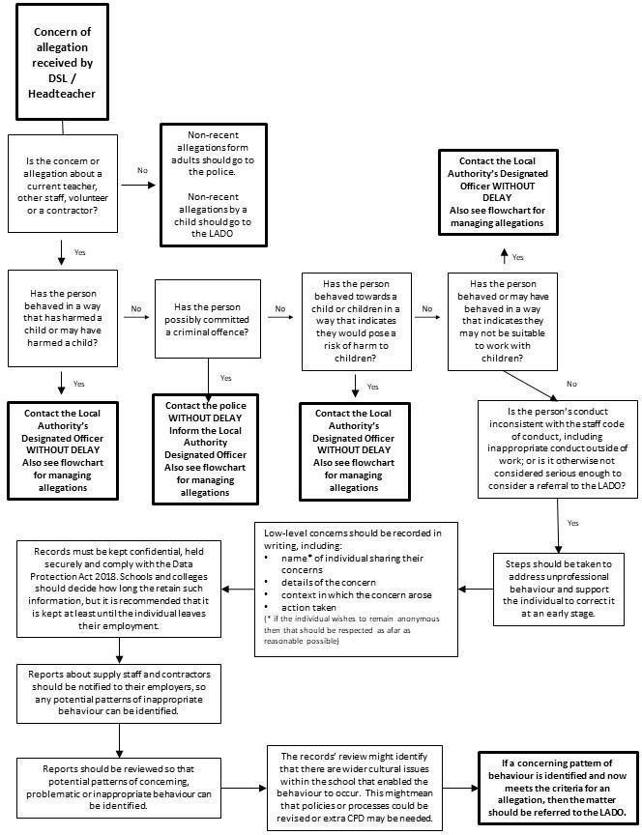

6. **Low level Concerns Reporting Form - Jordans Village Nursery School**

|  |  |  |
| --- | --- | --- |
| **Your details** | | |
|  | | |
| **Name** (optional) |  | |
| **Role** |  | |
| **Date and time of completing this** **form** |  | |
| **Details of individual (including yourself for self-reporting) whom the concern is about** | | |
| **Name** |  | |
| **Role** |  | |
| **Relationship to the individual reporting** eg manager, colleague |  | |
| **Details of concern** | | |
| **Please include as much detail as possible. Think about the following:** What behaviour and/or incident are you reporting? What exactly happened? Why does the behaviour and/or incident worry you? Why do you believe the behaviour and/or incident is not consistent with our Safeguarding Policy and other policies? | | |
| **Details of any children involved** | | |
| **Name(s)** |  | |
| **Next Steps** | | |
| **Are you willing to meet with the manager and DSL to discuss your concern?** Please circle as appropriate. | **Yes** | **No** |
| **Please state any other information** **that you feel is relevant to the processing**  **of this concern.** |  | |
| **Signature** |  | |

|  |  |
| --- | --- |
| **For use by Manager/safeguarding team upon receipt of the**  **concern** | |
| **Date and time concern received** |  |
| **Signature** |  |
| **Role** |  |
| **Actions to be taken and follow-up.** |  |

Jordans Village Nursery School

I have read and understand Jordans Village Nursery School’s Low Level Concerns Policy - September 2024

|  |  |  |
| --- | --- | --- |
| Name | Date | Signature |
|  |  |  |
|  |  |  |
|  |  |  |
|  |  |  |
|  |  |  |
|  |  |  |
|  |  |  |
|  |  |  |
|  |  |  |
|  |  |  |
|  |  |  |
|  |  |  |
|  |  |  |
|  |  |  |
|  |  |  |
|  |  |  |
|  |  |  |
|  |  |  |
|  |  |  |
|  |  |  |
|  |  |  |
|  |  |  |
|  |  |  |